EXPERIMENT — 5
Name: RIYA SHARMA K Roll No: 240701433

AIM
To analyze and document the tasks performed by users in a Food Ordering Mobile Application and to design the corresponding user flow diagram and wireframes using tools such as Lucidchart or Figma.

PROCEDURE
Step 1: Identifying User Tasks
The major tasks identified in the Food Ordering Application are:
- Searching for nearby restaurants.
- Viewing restaurant menus and selecting food items.
- Adding items to the cart.
- Applying coupons and proceeding to checkout.
- Making payment and confirming the order.
- Tracking delivery and rating the order.

Step 2: Document User Flows
- Searching for Nearby Restaurants Home Screen:
User opens the application and lands on the home screen.

Location Permission:
Application asks for location access to find nearby restaurants.

Restaurant Search:
User searches or browses restaurants.

Restaurant List:
Application displays a list of available restaurants with ratings and delivery time.

Select Restaurant:
User selects a restaurant to view the menu.

Flow
Home Screen → Location Permission → Search Restaurant → Restaurant List → Select Restaurant

Browsing Menu and Adding Items
Menu Page:
User views available food items in the selected restaurant.
Select Food Item:
User selects items they want to order.
Add to Cart:
Items are added to the cart. Flow
Restaurant Menu → Select Item → Add to Cart → Cart Page

Cart Management
Cart Page:
User reviews selected items in the cart.
Modify Quantity:
User can increase or decrease the quantity.
Apply Coupon:
User enters a coupon code for discount. Flow
Cart → Apply Coupon → Validate Coupon → Updated Cart

Checkout and Login
Proceed to Checkout:
User clicks checkout.
Login Verification:
If the user is not logged in, the system requests login.
Login Page:
User enters email or password. Flow
Checkout → Login Verification → Login Page → Checkout

Payment Process
Select Payment Method:
User chooses a payment method such as credit card, debit card, UPI, or cash on delivery.
Payment Processing:
User confirms the payment.
Payment Success:
System processes the payment successfully. Flow
Select Payment Method → Payment Processing → Payment Successful

Order Confirmation and Tracking
Order Confirmation:
System confirms the order and provides order details.
Track Delivery:
User can track the delivery status.
Rate Order:
After delivery, user rates the order. Flow
Order Confirmation → Track Delivery → Rate Order → End
Example Flowchart Breakdown Restaurant Browsing Flow
Steps:
- Open Application.
- Allow location access.
- Search restaurants.
- View restaurant list.
- Select a restaurant.

Food Selection Flow
Steps:
- Open restaurant menu.
- Select food items.
- Add items to cart.
- View cart.

Checkout Flow
Steps:
- Apply coupon if available.
- Proceed to checkout.
- Login if required.
- Confirm order.

Payment Flow
Steps:
- Select payment method.
- Enter payment details.
- Confirm payment.
- Receive order confirmation.

Delivery and Feedback Flow
Steps:
- Track order delivery.
- Receive order.
- Provide rating and feedback.
FLOWCHART:

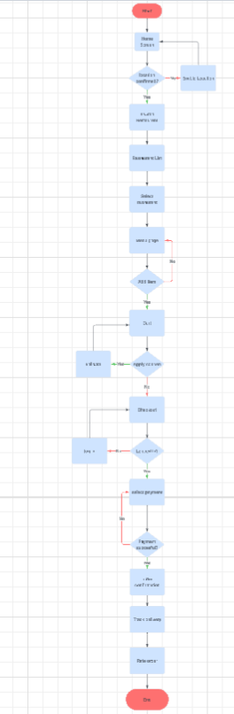
Wireframe
